House Renting Website

Login/SignUP:
- Can be multiple owners and multiple customers.
- Have to take as much information as possible for both owner and customers -
- Name-both owner & customer
- Age- must for both because underage cant be owner & customer
- NID- both
- Mobile number- both
- Permanent Residence- for customer only
- Family members- for customer only
- Email-both
- Job designation & description- for customers only.

Overall Idea:
- A random adult person can open an customers account and check if there is a vacancy in Building X’s Flat Y . He can also see data of the flat ( sqft, how many bed rooms blah blah). Then he can leave a request containing information about him if he wants to rent. So basically all flats To-let can be seen in the main dashboard for customers.
- A owner can verify or reject if someone wants a rent. He holds the power to evict someone ( delete from database) . He has to verify payment otherwise it will be shown pending. He will send an auto generated memo after he verify someones payment. Owners can create Tolet request in the dashboard for all. He will provide all data there. Owners can see his total revenue each month ( sum of all flats income). He will have a table wise where all the flats will be there with renters details to keep track if one person is due payment owners can see it marked.
- There will be a Rules & Agreement page in dashboard for all . No one can change it not owner not customers. ( chatgpt generated rules).
- After renting a customer can see owners details his phone numbers name etc. He will give payment give the transaction id in a form for owner to verify. A customer can create a To-let request. He can see his due payment. A customers payment date will be stored.

Features:
1. Flat Listing & Search (Customer)
- Browse available flats.
- Filter by area, price range, number of rooms, etc.
- Search by keyword
2. Flat Management (Owner)
- CRUD: Add, update, delete flats.
- Set status: Available / Rented / Under Maintenance.
- Attach images and descriptions.

3. Rental Request & Approval Workflow
- Customers request a flat → Owner approves/rejects.
- On approval: flat status → "Rented", rental record created.
- On rejection: request deleted or status changed.

4. Online Rent Payment (Customer)
- Pay monthly rent via simulated payment form.
- Record date, amount, payment method.
5. Late Payment Tracking & Red Marking
- If rent is not paid within 1 month → Customer is marked red.
- After 3 months → Auto-eviction:
- Rental is terminated.
- Flat becomes "Available" again.
6. Owner's Monthly Income Calculation
- Show a summary table:
- Month-wise rent received.
- Total income per month.
7. Customer's Due Tracking
- Show unpaid months + total due amount.
- Status messages: "No due", "1 month due", "3 months due - risk of eviction"
8. Customer Rental History
- Current flat with duration.(just difference of rental date and current date)
- Payment status per month.
9. Owner Dashboard: Current Tenants
- List all flats with current tenant info.
- Rent status (paid/unpaid), eviction risk.
- Option to terminate rental manually.
10. Complaints/Support System
- Customers lodge complaints.
- Owners/admins reply. ( not like text . Just like form from memo or verify)
- Track status: Open, In Progress, Resolved.

11. To-Let Auto Management
- When a rental ends (due to manual termination or eviction), the flat becomes available again and automatically appears in the “To Let” section.

Schema Diagram :
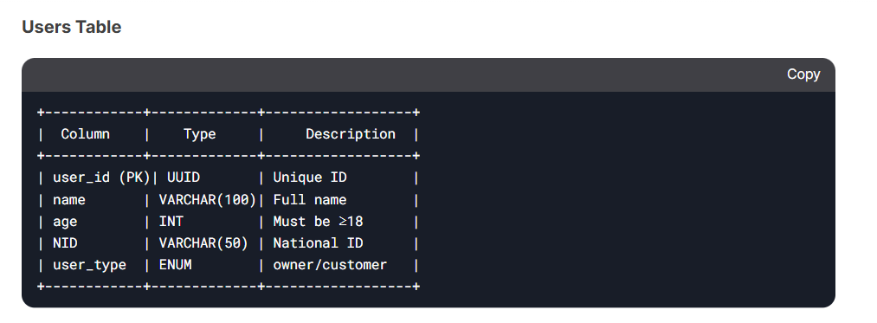
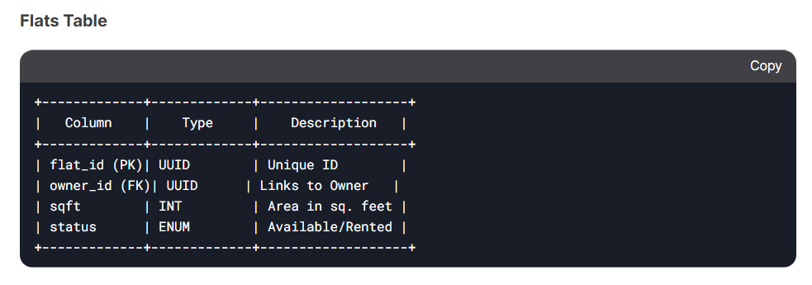
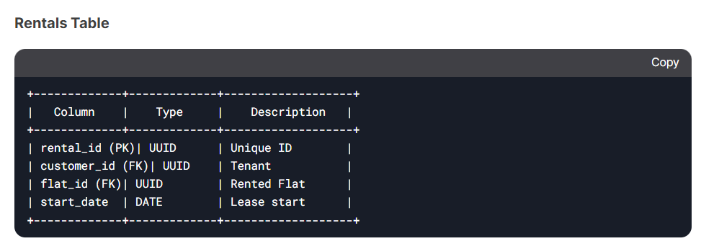

Flowchart:
